FOOD MOOD POO’D JOURNAL
Instructions:
In the pages following please record EVERYTHING you eat or drink for 2 days along with your mood (how you felt), how well you slept, and what your poo was like (use the chart below for help). Include the time of day that you poo’d. I know this seems weird and uncomfortable, but it tells me a lot about what’s going on with your digestion. Choose any 2 days - choose 1 week day and 1 weekend day if possible, otherwise any 2 days are fine.
When filling this out, eat your usual diet. Don’t change anything that you would normally eat. It’s important to be as honest as possible about what is normal for you, otherwise it will affect the way I interpret your results. There is no judgement here, just an investigation into what’s going on in your body.
Be as detailed as you can when recording the food in terms of type and amount. For example, instead of saying ‘cereal’, write ‘½ cup of Weet-bix with ½ cup of whole milk’. This is much more helpful for me. You don’t need to measure anything exactly, but take your best guess.
Don’t forget to write down all the little extras such as added butter on potatoes, spreads on sandwiches, sandwiches, milk with cereal, cooking oil or fats, etc. This is not meant to be stressful for you! The details just help me to analyse your health better.

Words for poop | Words for mood | Words for sleep
Soft | Happy | Easily fell asleep
Hard to pass | Ecstatic | Pleasant dreams
Pebbly | Sad | Wired/couldn’t fall asleep
Runny | Stressed | Thinking too much
Formed/sausage shaped | Hyperactive | Finally fell asleep exhausted
Green | Flat | Daytime sleep needed
Yellow | Teary | Restless sleep
Brown | Angry | Constant waking
Black | Frustrated | Hard to wake up
Has mucus in it | Down or depressed | Nightmares
Has food in it | Anxious | Overslept
Floats | Sluggish | Woke up refreshed
Sinks | Foggy head | Felt rested

Please circle if this is a Weekday Weekend

Time | Food/Drink | Mood | Poop
Morning

Mid Morning

Lunch

Mid-afternoon

Dinner

Evening

Sleep

Please circle if this is a Weekday Weekend

Time | Food/Drink | Mood | Poop
Morning

Mid Morning

Lunch

Mid-afternoon

Dinner

Evening

Sleep

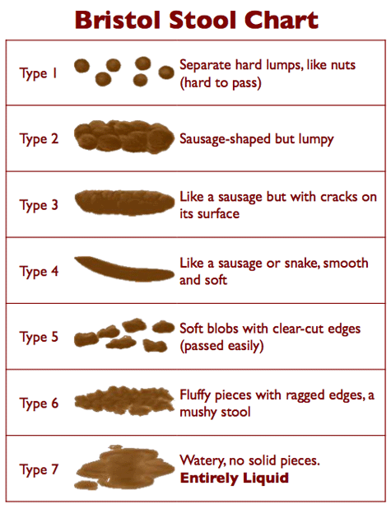
Continence.org.au. (2018). Bristol stool chart · Faecal · Continence Foundation of Australia. [online] Available at: http://www.continence.org.au/pages/bristol-stool-chart.html [Accessed 15 June. 2018].

